Batch Payroll System
Qasim
16053

Class Diagram
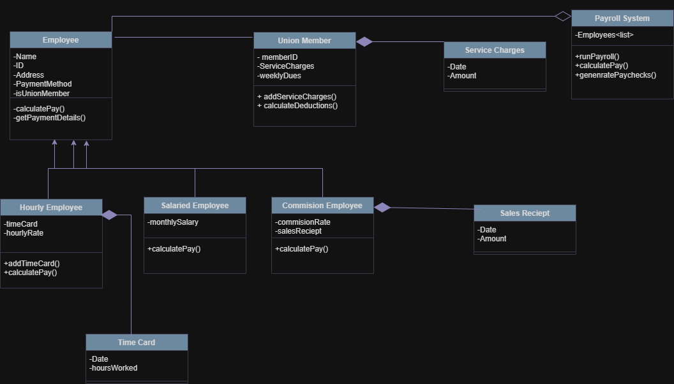
Code:
using System;
using System.Collections.Generic;

public class Employee
{
private string name;
private int ID;
private string address;
private string paymentMethod;
private bool isUnionMember;

public virtual double calculatePay()
{
// TODO implement here
return 0;
}

public void getPaymentDetails()
{
// TODO implement here
}
}

public class HourlyEmployee : Employee
{
private List<TimeCard> timeCard;
private double hourlyRate;

public void addTimeCard(TimeCard card)
{
// TODO implement here
}

public override double calculatePay()
{
// TODO implement here
return 0;
}
}

public class SalariedEmployee : Employee
{
private double monthlySalary;

public override double calculatePay()
{
// TODO implement here
return 0;
}
}

public class CommissionEmployee : Employee
{
private double commissionRate;
private List<SalesReceipt> salesReceipt;

public override double calculatePay()
{
// TODO implement here
return 0;
}
}

public class TimeCard
{
private DateTime date;
private double hoursWorked;
}

public class SalesReceipt
{
private DateTime date;
private double amount;
}

public class UnionMember
{
private int memberID;
private List<ServiceCharge> serviceCharges;
private double weeklyDues;

public void addServiceCharges(ServiceCharge charge)
{
// TODO implement here
}

public double calculateDeductions()
{
// TODO implement here
return 0;
}
}

public class ServiceCharge
{
private DateTime date;
private double amount;
}

public class PayrollSystem
{
private List<Employee> employees;

public void runPayroll()
{
// TODO implement here
}

public void calculatePay()
{
// TODO implement here
}

public void generatePaychecks()
{
// TODO implement here
}
}

